PRESS RELEASE
Wayne Stellmach
Wilbert Funeral Services, Inc.
708-865-1600 x166
wstellmach@wilbert.com
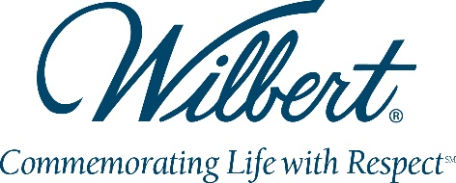

For Immediate Release

TWELVE wilbert licensees recognized for special achievements

BROADVIEW, IL, February 8, 2017 – Twelve Wilbert Licensees were recognized for sales accomplishments at the Wilbert Funeral Services, Inc (WFSI) Annual Sales Meeting recently held in Houston, Texas.

Whited Cemetery Service, Menifee, CA received both of the top awards for sales growth in lined burial vaults, achieving the greatest increase in the number of burial vaults interred in 2016 over 2015, as well as the greatest percentage increase year-over-year.

For cremation product sales, Arnold Wilbert Corporation, Goldsboro, NC earned the award for the greatest growth in units. Windsor Vault Co. Limited, Maidstone, ON, Canada achieved the greatest percentage growth in cremation products.

Also related to cremation products is the WilbertDirect award achieved by Baxter Burial Vault Service, Inc., Cincinnati, OH, which recognizes the greatest growth in sales on the WilbertDirect ecommerce website.

Ten Wilbert Licensees received the Wilbert 110% Club award, which recognizes those whose 2016 burial vault sales were at least 110% of their 2015 sales. Recipients were:
Whited Cemetery Service, Menifee, CA
Knauer Industries, LLC, Joliet, IL
Wilbert Vault Works, Hudson, NY
Brown-Wilbert, Inc., Fargo, ND
The Akron Vault Co., Akron, OH
Evans Burial Vaults, Leola, PA
Lycoming Burial Vault Co., Inc., Montoursville, PA
Wilbert Funeral Services, Austin, TX
Wilbert Funeral Services, Cedar Hill, TX
Windsor Vault Co. Limited, Maidstone, ON, Canada

“These special achievements illustrate the dedication and excellent service these Licensees provide to funeral professionals and the families they serve,” said Mark Klingenberger, Vice-President Sales & Marketing, WFSI. “Ultimately it’s all about the experience that families receive and the quality of the products and excellence of the service help frame a good experience. Congratulations to these Wilbert Licensees for their exceptional accomplishments.”

To learn more about Wilbert Funeral Services or to find a local Wilbert Licensee, visit WFSI’s Funeral Professional website at www.wilbert.com/funeral-professionals.
# # #

