PRESS RELEASE
Wayne Stellmach
Pierce / The Wilbert Group
708.681.7616
wstellmach@wilbert.com
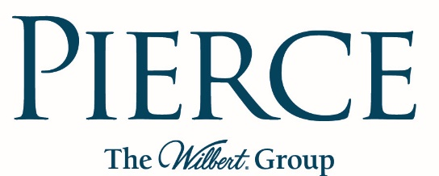

FOR IMMEDIATE RELEASE

pierce sales representatives earn special achievement awards

BROADVIEW, IL, February 20, 2017 – Pierce Chemical was honored to present sales achievement awards to four Regional Sales Representatives and one Distributor at their annual Sales Meeting recently held in Houston, Texas.
Jason Thornhill was awarded the distinguished Bill Pierce Award, given to one who demonstrates exemplary professionalism and above-and-beyond efforts. Jason was recognized for his positive, can-do attitude and dedication to his customers, helping them solve their embalming-related problems. Jason covers the states of Georgia and Florida.
Ryan Lee earned three awards, an outstanding achievement particularly as one of those was the 2016 Rookie of the Year award. Ryan has been a sales rep for the states of California, Hawaii and Nevada for just over one year, yet grew the territory so quickly that he also won Top Memorial Book Sales Growth and Top Sales Growth Overall, increasing overall sales by thirty percent.
David Hicks, who covers the states of Ohio, Kentucky and West Virginia, was given the award for Top Cosmetics Sales Growth in 2016.
Don Summers achieved the 2016 Top Urn Sales Growth award. Don’s territory is the state of Texas.
American Wilbert Vault Corp., based in Bridgeview, Illinois, received the 2016 Top Distributor Sales award. Pierce has distributor organizations in certain markets.
“Outstanding sales growth does not happen by itself and these achievements illustrate the professionalism and perseverance of all who earned these awards,” said Lance Ray, COO and Executive Vice-President of Pierce. “It’s the focus on their customers that provides their motivation and drives their success – that is truly what we’re celebrating with these awards.”
For more information on Pierce, visit www.piercechemical.com.
# # #

